**Q1. Capture and analyze ARP packets using Wireshark. Inspect the ARP request and reply frames when your device attempts to find the router's MAC address.Discuss the importance of ARP in packet forwarding.**

**Using ping command with 192.168.1.1:**

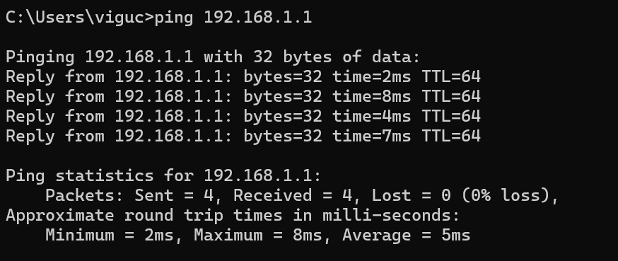

**Capturing packets using Wireshark:**

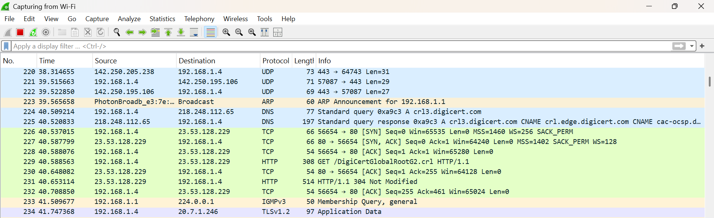

**Filtering the arp packets:**

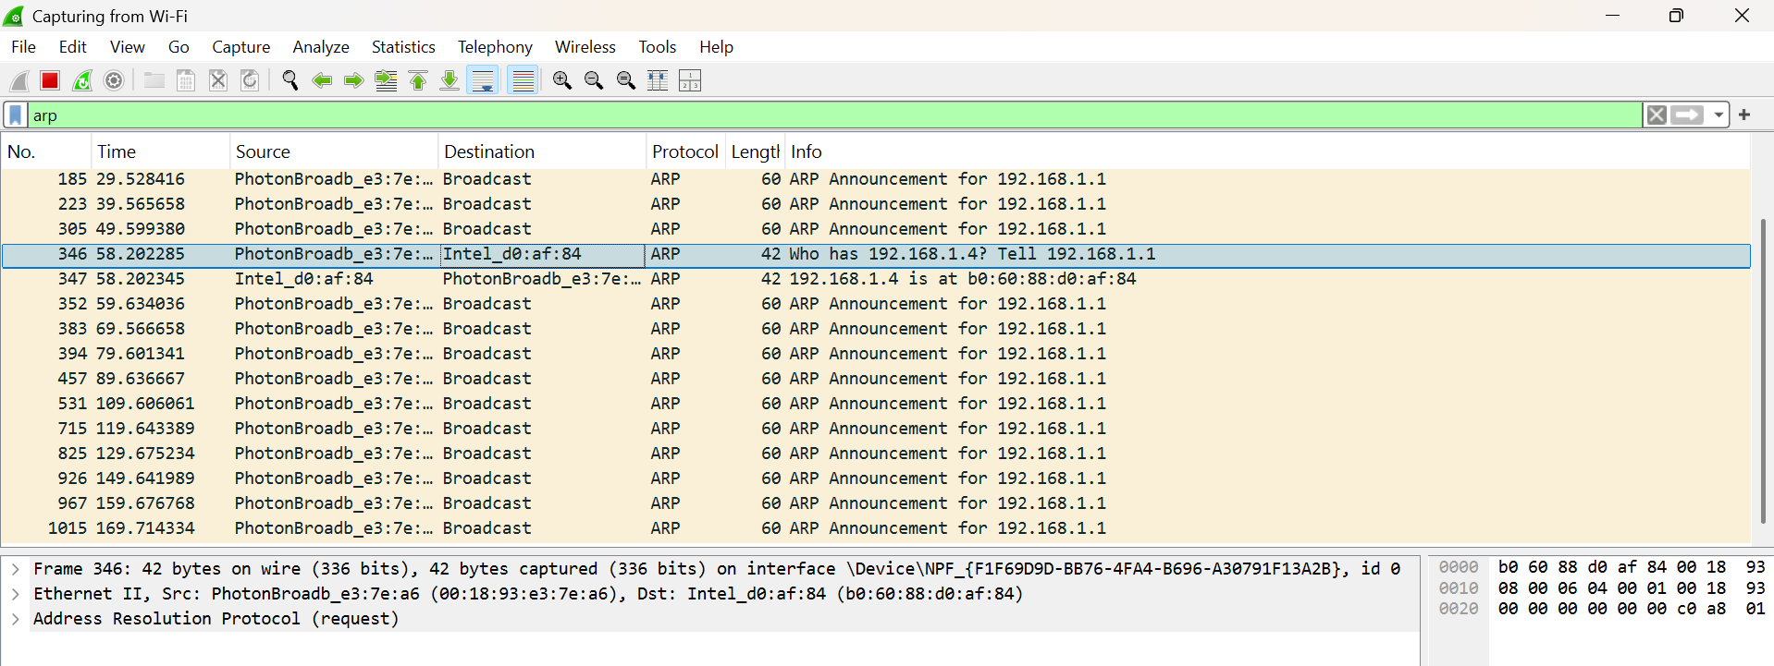

**ARP table:**

